Project Report
Ride Sharing System

Submitted by:  Bismoy Sarker  Roll: 2407008  Avik Hasan  Roll: 2407021  Farhan Hossain  Roll: 2407019 | Submitted to:  Subah Nawar  Lecturer  Department of Computer Science and Engineering  Khulna University of Engineering & Technology  Lamisa Bintee Mizan Deya  Department of Computer Science and Engineering  Khulna University of Engineering & Technology
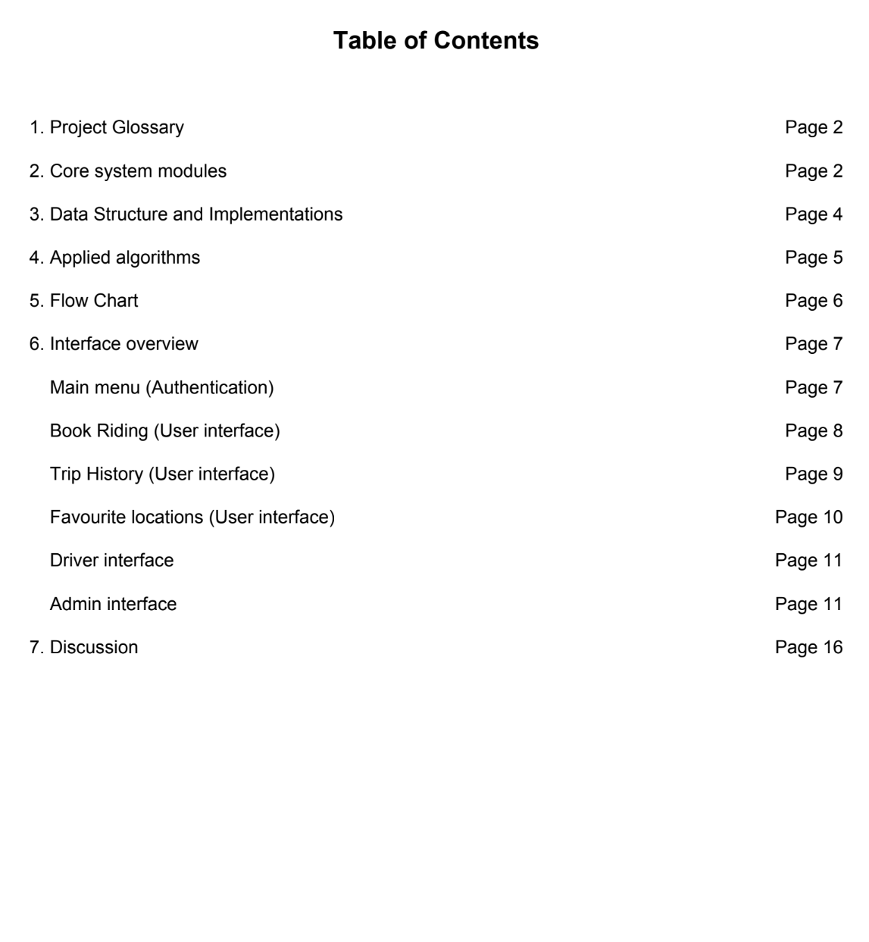

1. Project Glossary
This project is a comprehensive, console-based Ride-Sharing and Transportation Management System developed in C++ using the algorithms of basic data structure that has been taught over the last lab experiments. This project models real-world ride-hailing mechanics including driver-rider matching, dynamic surge pricing (based on weather, traffic, and demand), wallet management, and map routing. The project implemented all the necessary algorithms which is needed to develop any real life simulating system.

2. Core system modules
- Admin Dashboard:
Through it,one can have centralized control over the system. The admins can view earnings,manage pricing tiers(i.e Bikes,CNG,UberX),alter surge parameters(i.e traffic/weather multiplier ) and approve wallet top up requests
- Driver management:
Through it, one can maintain their driver profile.These portal supports to view their profile &earnings ,Toggling their active status,looking up to their trip history and updating their current location
- User/Passenger interface:
This interface allows users or passenger to book their ride,show their latest trip history,adding money in their wallet or checking balance and adding their favourite locations, All these features leverages a user’s riding experience

- Authentication Systems:
Secure login system is a pre requisite for any real life simulation model. So our project has a unique verification process for users,drivers and admins. It requires username and password which has to be unique otherwise the access is denied.

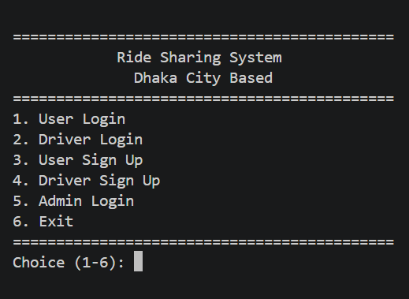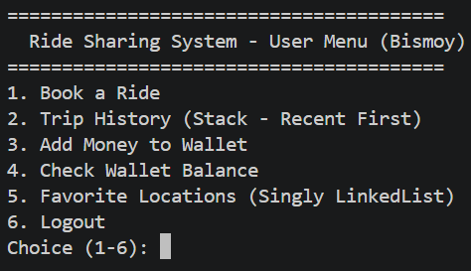
Fig 1:Main menu Interface Fig 2:User menu Interface
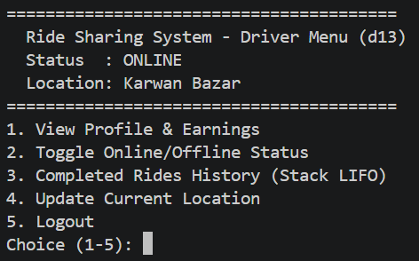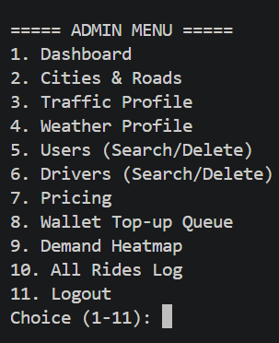
Fig 3:Driver menu Interface Fig 4:Driver menu Interface

3. Data Structure and Implementations
To increase the performance and efficiency of the system, different types of data structures and sorting algorithms are used. Also we have used self-made custom data structures that helps the system to perform on its vast data more easily and rapidly.

Data Structure | Implementation and file reference | System use Case
Binary Search tree(BST) | UserAccountBST(bst.cpp) | Used to store and search Rider profiles by ID. Enables fast O(log n) lookups, insertions, and deletions when the admin is querying millions of potential users.
Weighted Graph | CityGraph(graph.hpp) | Represents the city layout. Nodes represent cities, and weighted edges represent road distances. Used for routing and calculating base fare per kilometer.
Dynamic Arary | Vector<T>(vector.hpp) | A custom templated array that scales automatically. Used extensively across the platform to maintain drivers, ride logs, and leaderboard indices.
Stack | Stack<T>(stack.hpp) | Used internally within specific graph traversals and path tracking.
Queue | WalletRequestQueue(queue.cpp) | Used in admin interface and bfs traversal to store value temporarily
Linked list | SinglyLinkedList(linkedlist.hpp) | Used vastly in graphs,and riders’s favourite location.
Min heap | matchDriver(heap.cpp) | Used in the function to determine the available drivers closest to the passenger’s location.

4.Applied algorithms
- Recursive Binary Search:
This searching algorithm used within”DriverModule” to execute lightning-fast searches against the driver dataset. The “searchDriverByRBS” function queries the array of DriverInfo objects
- Merge sort:
The driver leaderboard ranks drivers based on earnings, completed trips, and ratings. A custom mergeSortDriverLeaderboard algorithm sorts the driver indices safely without copying large user objects in memory.
- Selection Sort:
Used in generating the Demand Heatmap, The getTopDemandSelectionSort function parses historical trip data (rides.csv) .This calculates frequency per city and sorts them to display the most requested areas for both driver and passenger.
- BFS:
This algorithm used in graph.cpp for calculating the shortest path between the passenger’s pickup spot and his destination. It replaces any complex algorithm like Dijkstra's algorithm .It’s calculates the shortest route accurately using queue,
- DFS:
This algorithm is used in graph.cpp for printing the alternative route along with the shortest path between passenger’s pickup and destination.It uses stack to display the places accordingly.

5.Flow Chart
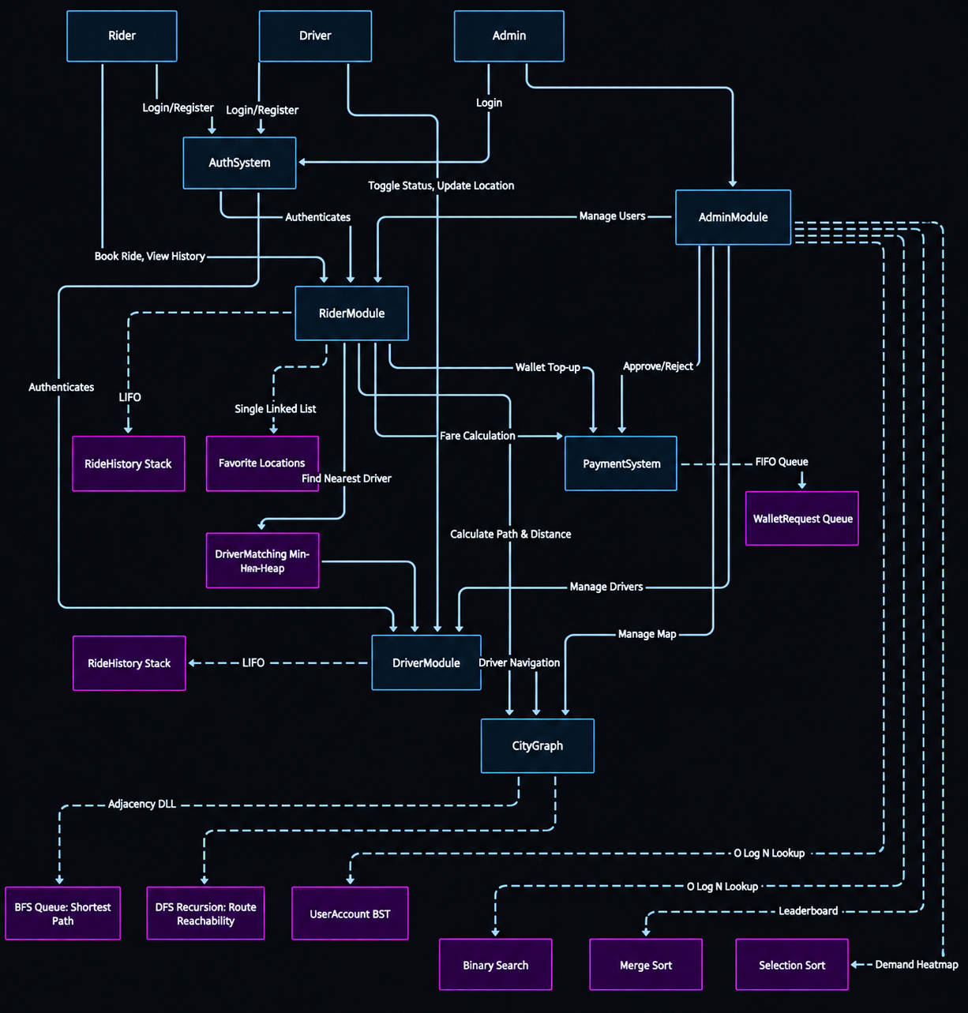

6.Interface overview
- Main menu(Authentication):
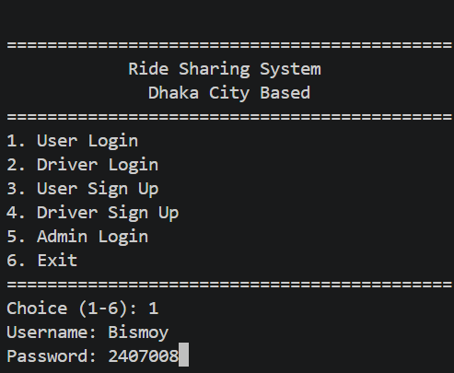
Here at first ,the person’s identity is verified through unique username and password,which is already preserved in users.csv,drivers.csv file.It is performed through the AuthSystem class which interacts with both the RiderModule and DriverModule to verify credentials and assign user roles .The following code snippets provides the necessary functions
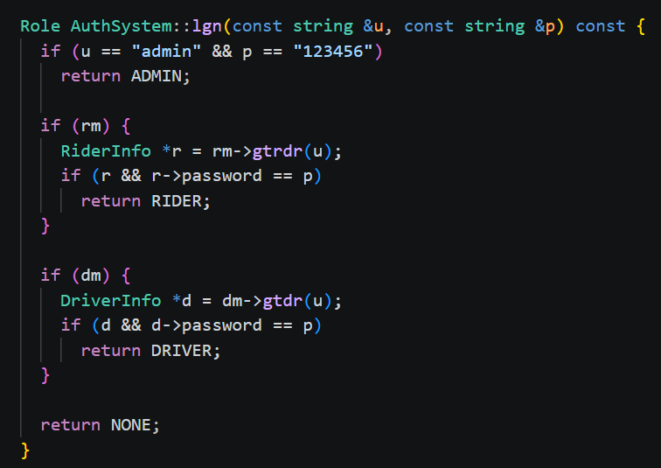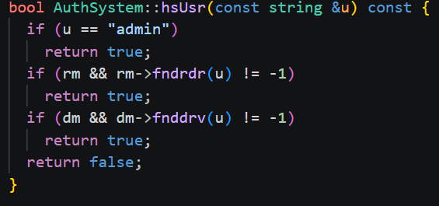
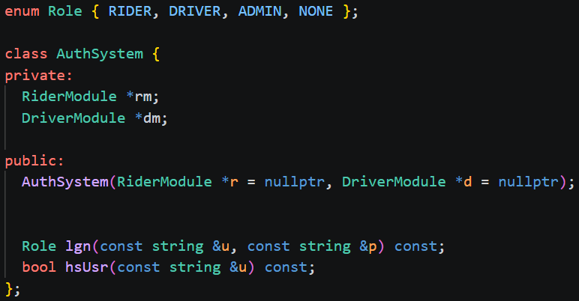
- Book Riding(User interface)
In the user interface whenever the passenger selects book a ride,the system prints the location list . Then the passenger chooses his pickup and destination through indexing. Then he selects his vehicle type which determines the fare .Finally after confirmation a dynamic print is shown which prints his travelling path .Here are some snippets
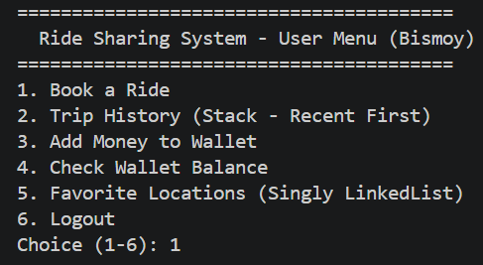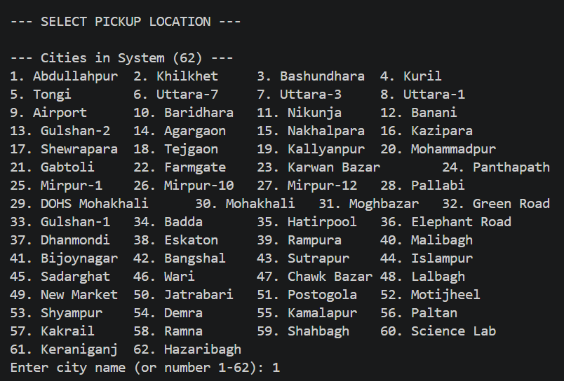

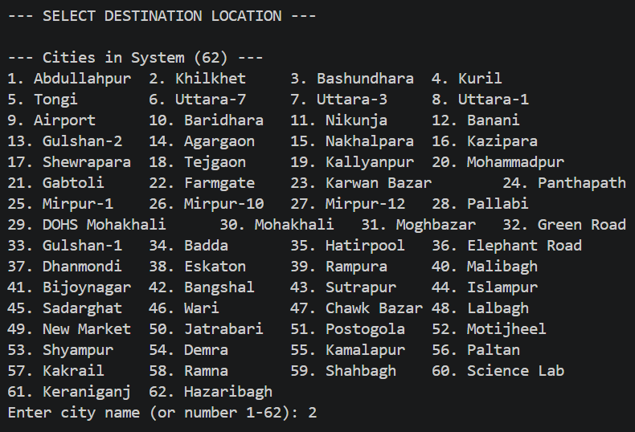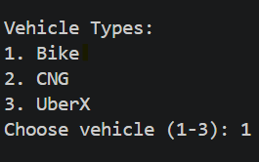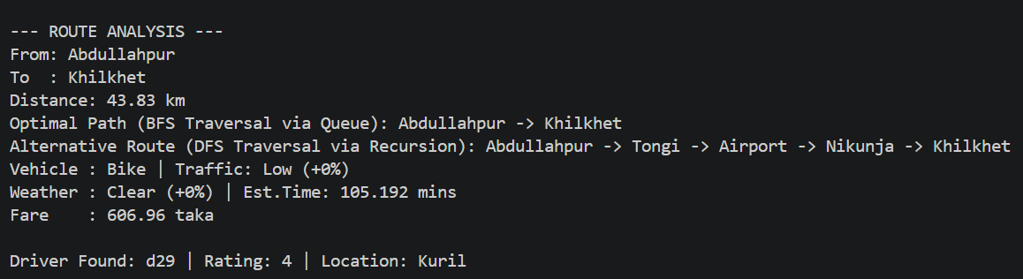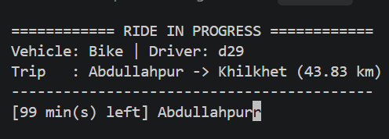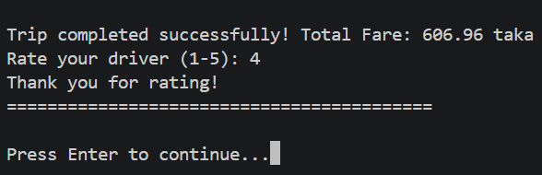

The whole process is done by using graph for calculating the nearest path using bfs and Mean heap to search the nearest driver in that location.The drivers are shown in Descending order based on their ratings (If tied then trip counts). Here are some code snippets
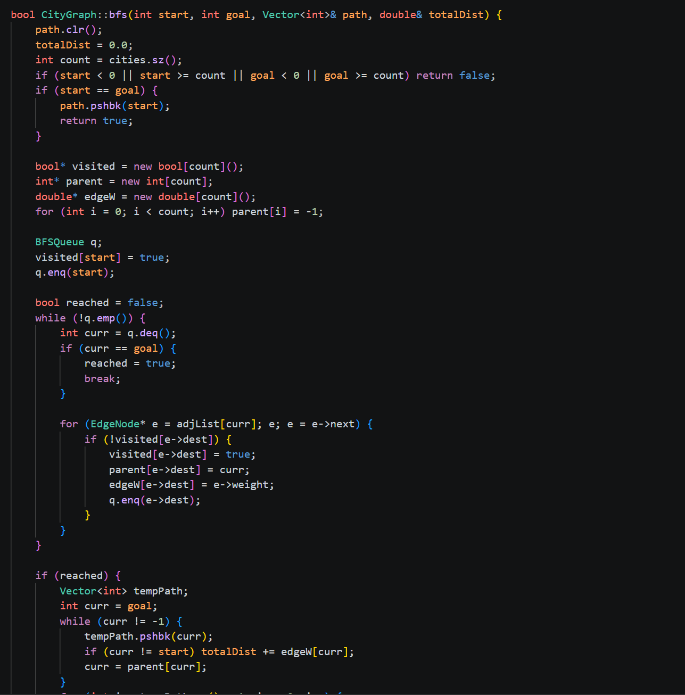
- Trip History(User interface):
This feature allows the passenger to print his trip history in the console
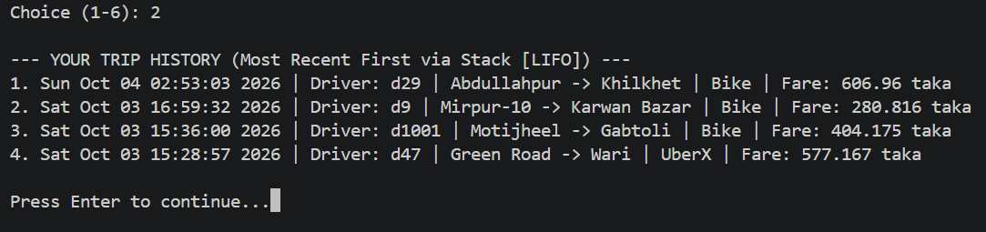
This is implemented by customized stack which appends the data from rides.csv file.The stack is situated in stack.cpp here is some snippets
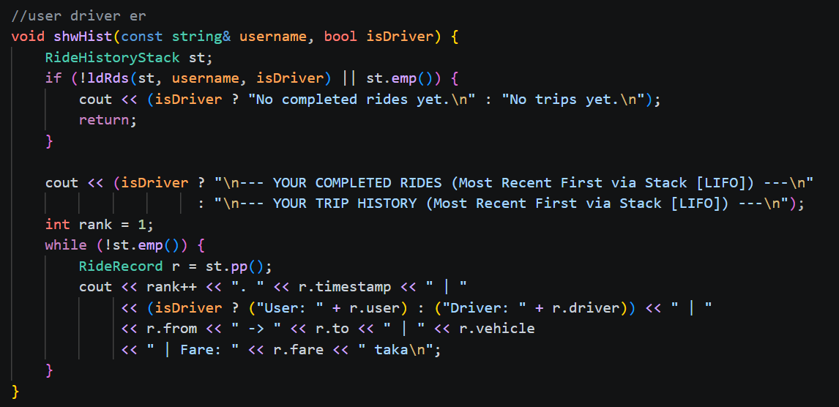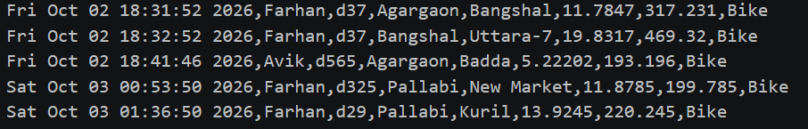
- Favourite locations(User interface):
This feature allows the user to add ,show and delete his favourite locations. In this case, a singly linked list from linkedlist.cpp is used. It stores the favourite location in the user.csv file. And in case of adding and removing it just adds or deletes the node
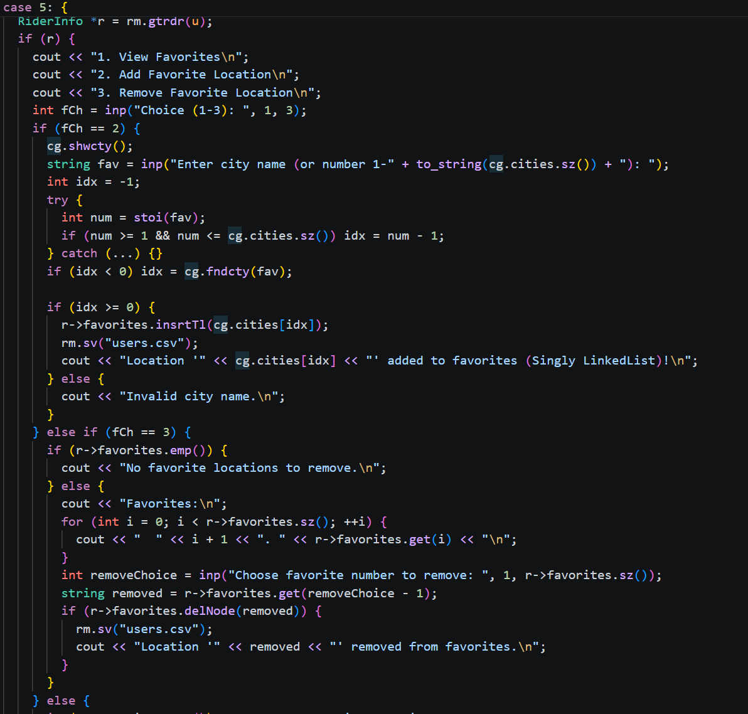

- Driver interface:
In this interface ,the employed drivers can see their profile and earnings,toggle his status,ssee his ride history and can update his current location .This interface is also similar to user interface as both of them almost use the same functions and modules here is the snippet of the interfaces
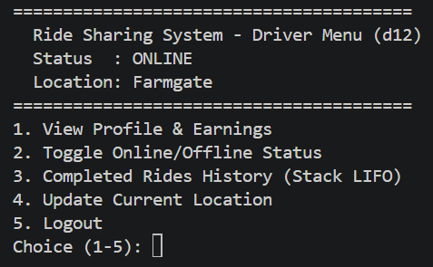
- Admin interface:
It is executed by AdminModule which handles vital systems totals including active riders,approval of top ups,identifying top demanding area,updating prices,printing logs and others. In short , the most versatile and efficient operations are done here in admin panel,
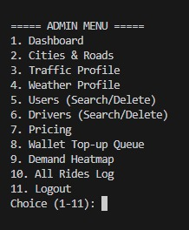

Cities & Roads (Map Management)

View Map | Handled by AdminModule::viewMap(). This function parses the adjacency connections from connected_nodes.csv and visually prints the entire road network structure to the console.
Add / Remove City | Executed by AdminModule::addCity() and AdminModule::removeCity(). These functions interact directly with the core CityGraph object to mutate the map nodes, subsequently updating the connected_nodes.csv data store.
Add / Remove Road | Executed by AdminModule::addRoad() and AdminModule::removeRoad(). These utilize the selectTwoCities() helper function to prompt and validate the edge connections (distances) between specific graph nodes before saving.

User (Rider) Management

Search User | Managed by AdminModule::searchUserByBST(). This leverages the Binary Search Tree algorithm via UserAccountBST::search() to quickly find a user with a time complexity of O(log N).
Delete User | Handled by AdminModule::removeUser(), which locates the specific rider and completely removes the user from both the RiderModule data structure and the underlying userBST lookup tree.
List All Users | Executed by AdminModule::listAllUsers(), which subsequently triggers RiderModule::displayAllRiders() to print a formatted list of all registered passengers.

Driver Management

Search Driver | Handled by AdminModule::searchDriverByRBS(). It queries the system by calling DriverModule::getDriverByID() and utilizes the binarySearchRecursive() algorithm for rapid execution.
Driver Leaderboard | Generated within AdminModule::handleDriverMenu(), which calls DriverModule::getLeaderboard(). This returns the top drivers sorted by their rating and earnings using the robust Merge Sort algorithm.
Delete Driver | Executed by AdminModule::removeDriver(). The process locates the driver via DriverModule::getDriver() and purges them completely from the system's runtime and storage.
List All Drivers | ecuted by AdminModule::listAllDrivers(), which iterates through the storage vector by invoking DriverModule::displayAllDrivers().

Wallet & Financial Systems

View Wallet Queue | Triggered by AdminModule::handleWalletMenu(), which invokes AdminModule::viewWalletRequests() to display a list of all pending fiat-to-digital balance top-up requests.
Approve / Reject | Processed directly within AdminModule::handleWalletMenu() by invoking PaymentSystem::approveFirstRequest() to securely credit the user's wallet, or PaymentSystem::rejectFirstRequest() to deny the transaction and clear the queue item.
Pricing Config | Handled by AdminModule::handlePricingMenu(). This interface allows the admin to update variables like pm.demandWeight, pm.maxSurgeCap, and individual vehicle base fares, immediately saving the results to pricing_config.csv.

Data Visualization & Profiles

Demand Heatmap | Executed by AdminModule::showDemandHeatmap(). This feature parses rides.csv and utilizes getTopDemandSelectionSort() to rank and display cities strictly by ride request volume.
All Rides Log | Handled by AdminModule::viewSortedRides(), which loads and displays the global historical trip data across the entire platform.
Traffic & Weather | Managed by AdminModule::editTrafficProfile() and AdminModule::editWeatherProfile(). Both functions route into the generic helper editGenericProfile() to modify and store dynamic surge multipliers for specific hours of the day.

Here some code snippets are added
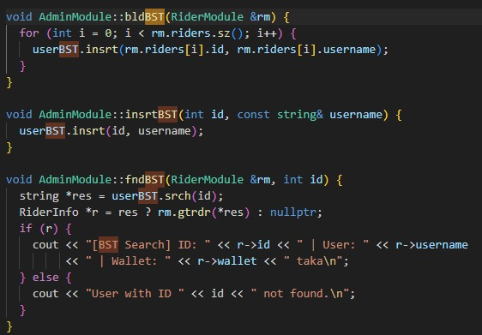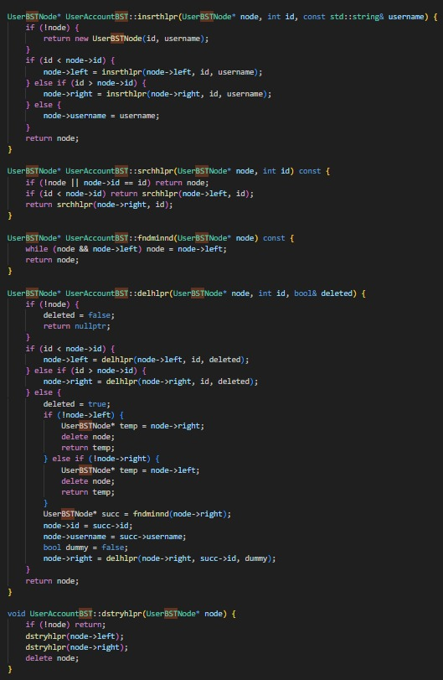
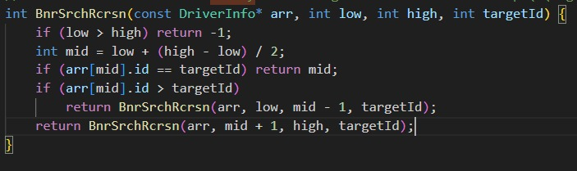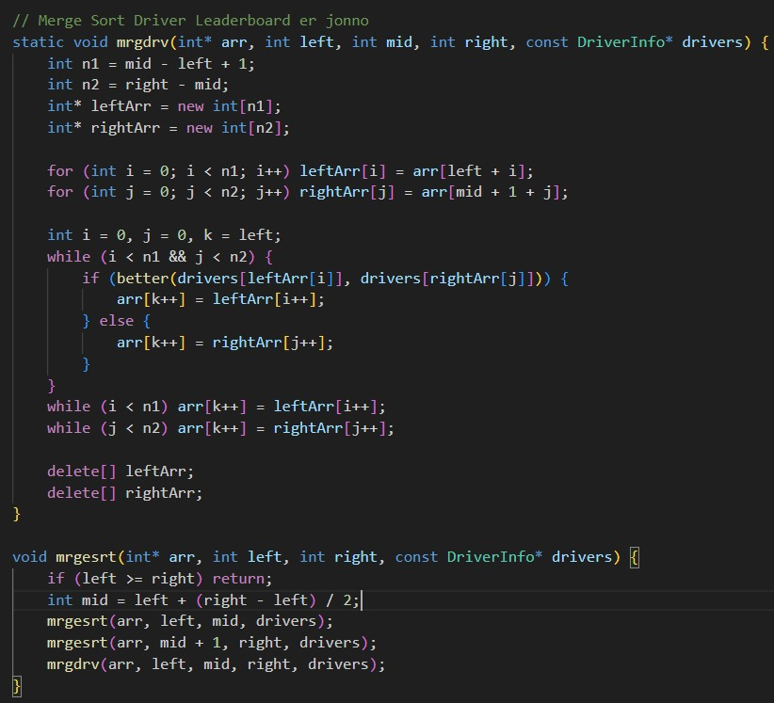
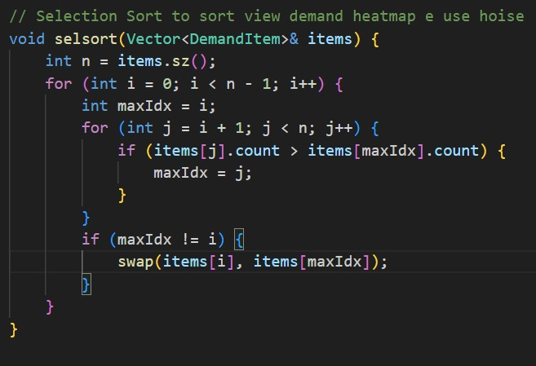
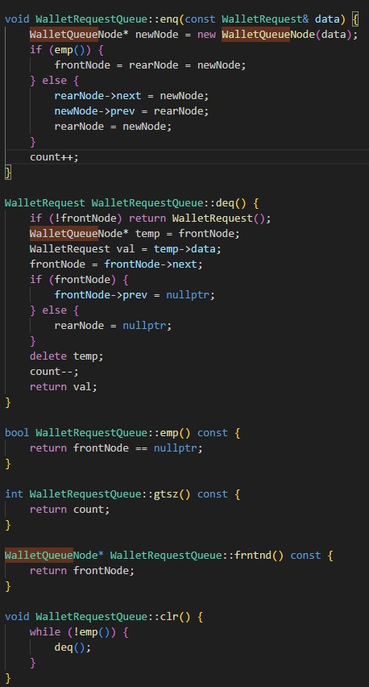

6.Discussion
Custom Data Structure Implementation
The project prioritizes optimized manual memory management by building fundamental data structures from scratch rather than defaulting to standard libraries.
- Spatial Routing (Graphs): The city network is mapped using a CityGraph adjacency list. This allows the application to execute Breadth-First Search (BFS) and Depth-First Search (DFS) algorithms to validate paths and compute travel distances between nodes.
- Fast Retrieval (Trees & Heaps): A Binary Search Tree (BST) architecture executes user lookups in $O(logN)$ time. Driver matching is accelerated using a custom Min-Heap (DriverMatchingMinHeap), which instantly extracts the most optimal available driver for a new ride request.
- Sequential Processing (Stacks & Queues): Financial transactions, such as wallet top-ups, are managed equitably through a Doubly Linked List-backed FIFO Queue. Conversely, individual trip logs enforce chronological integrity by pushing and popping records via a LIFO Stack, ensuring the most recent rides are always accessed first.
Algorithmic Efficiency
Administrative sorting and searching tasks are paired with algorithms suited to their specific computational constraints. Merge Sort ($O(NlogN)$) handles the driver leaderboard, providing a stable, high-performance sort as the driver pool scales. Selection Sort is applied to generate the demand heatmap, offering a low-overhead solution for smaller, localized arrays. Recursive Binary Search is utilized to parse the driver arrays, cutting down search times significantly compared to linear iteration.
Data Persistence
The application maintains absolute state consistency across execution cycles through flat-file storage. Data is serialized and deserialized into CSV formats (rides.csv, connected_nodes.csv, pricing_config.csv). Complex nested data, such as a rider's SinglyLinkedList of favorite locations, is successfully preserved using specialized delimiters (semicolons) alongside standard comma separation.
The integration of these custom data structures and OOP principles results in a cohesive simulation of a high-throughput ride-hailing backend. The application strictly enforces algorithmic efficiency, mirroring the low-latency requirements of real-world transactional systems. The dynamic pricing engine—which calculates fares by parsing concurrent weather profiles, traffic conditions, and peak demand weights—adds practical economic logic to the software's capabilities.
Because the backend logic is highly modular and independent of the user interface, the existing C++ framework provides a direct pathway for future expansion. The current flat-file persistence layer can be smoothly swapped for a relational database, while the core routing and matching engines are well-structured for integration into a graphical interface, network-based API, or real-time coordinate tracking system.

